Guide 2. APT Project Development
Capstone Course

1. APT Project Progress Summary

APT project progress summary | The “Alerta Vital” project is currently in the development phase, specifically in “Sprint 4: Advanced Features and Integration,” which will begin the week of October 13. The team is actively working to meet the established deadlines. To date, we have completed the Start and Planning (Sprint 1), Design and Prototype (Sprint 2), and Development - System Core (Sprint 3) stages.  - ● Completed activities:  - ○ Sprint 1 (Initiation and Planning): We brainstormed and gathered functional and non-functional requirements. We also defined the scope and Minimum Viable Product (MVP) of the project, designed the architecture, and selected the technologies.  - ○ Sprint 2 (Design and Prototype): We created the interface prototype (UI/UX) and designed the database schema. We also designed the backend REST API.  - ○ Sprint 3 (Development - System Core): This sprint was crucial for the development of the main functionalities. We completed the initial creation of the database schema, migrations, and seeders. The backend was developed, including user registration, the connection between the senior citizen and their trusted contacts, geolocation, the countdown for alerts, and notifications. We also worked on the frontend, creating the base structure, navigation, and registration and countdown templates.  - ● Objectives achieved and adjustments:  - ○ Objectives achieved: We have completed the initial and development phases of the core system, establishing a solid foundation for more advanced features. We have completed the creation of the basic backend and frontend, the implementation of geolocation, and the alert system.  - ○ Adjustments: Initially, the project focused on fall detection using cell phone sensors and machine learning to send alerts. This objective was discarded to simplify the technical complexity and changed to the implementation of machine learning to detect the closest trusted contact once the alert button is pressed. Another adjustment was the elimination of the alert system using the WhatsApp API, which was also discarded due to the costs associated with this tool.  - ○ Methodology: The methodology has remained unchanged. We followed an agile approach based on sprints, which allowed us to effectively adapt to the adjustments made and maintain the execution of the project. The detailed Gantt chart shows how we progressed through each sprint.
Objectives | Previous  - Implement a geolocation module to detect which emergency contact is closest based on rules and lightweight machine learning for greater accuracy.  - Design and integrate an alert system with countdown and SMS messages with geolocation to predefined contacts.  - Develop a backend in Node.js with PostgreSQL to manage events, contacts, and emergency responses.  - Incorporate digital accessibility principles into the user interface, with clear typography, large buttons, and audible and vibrating notifications.  - Validate the application's performance through simulated tests in controlled environments and adjust parameters according to the results obtained.  NEW  - Create a monitoring app for older adults with an alert button, real-time geolocation, and notifications to emergency contacts.  - Develop a robust platform with node.js and postgreSQL (backend), Flutter (mobile), and REST API, integrating map services and push notifications.  - Implement a machine learning model to automatically geolocate by analyzing which emergency contact is closest.  - Design a simple and accessible interface with large elements and intuitive navigation for older adults.  - Include medication reminders, a calendar of medical appointments, and alerts for leaving defined safe zones.  - Perform exhaustive testing and professional deployment with complete documentation for users and technicians.
Methodology | No change in methodology
Evidence of progress | Various examples of technologies and codes used in this project will be shown, from organizing tasks using Trello to Visual Studio Code, where the project is coded.  Trello: To organize and assign tasks among members.  App features: registration, caregiver-senior citizen pairing, prototype, map, alerts, countdown, etc.  Figma: we use it to create a prototype of how we want the app to be.  Visual Studio Code: to write, edit, debug, and run source code efficiently.  PostgreSQL:  Git Hub: host and share code online using the Git version control system.  Postman: to test, develop, and document APIs.

Images:

Prototype
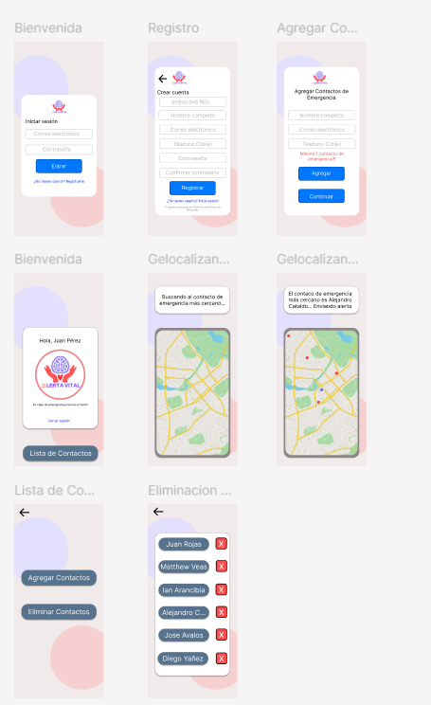

Github
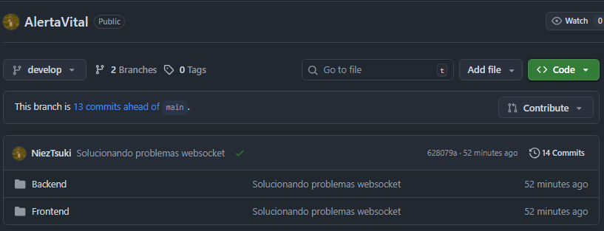

Assigning tasks in Trello
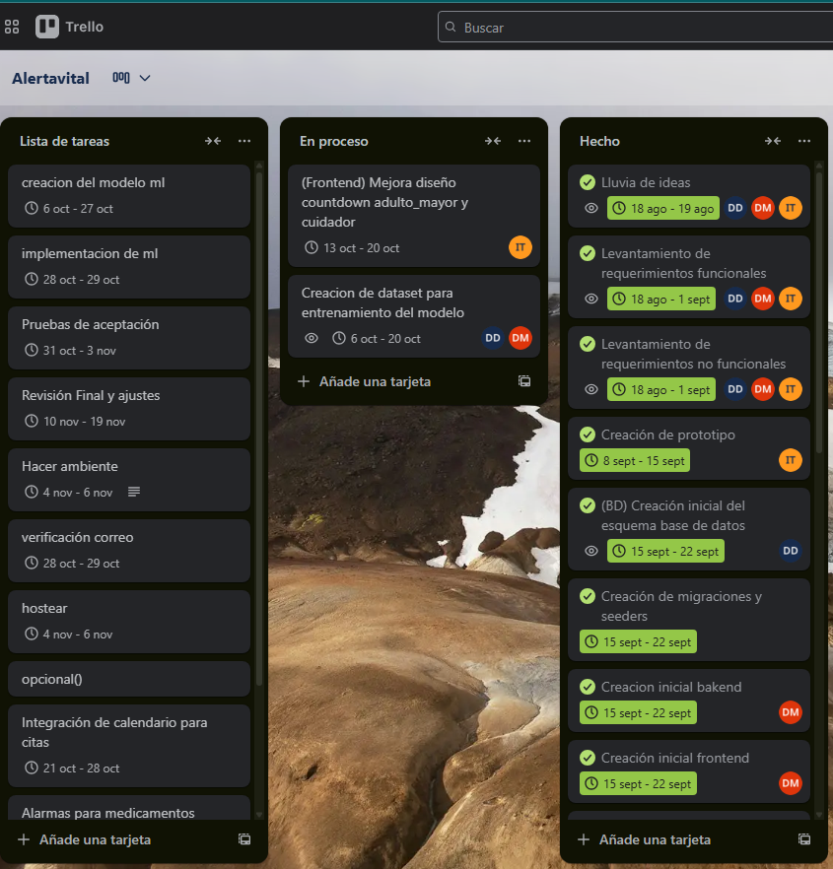

Project structure (codes)
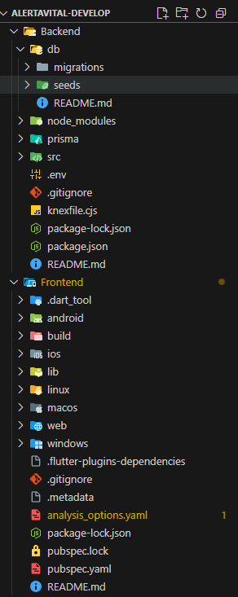

DB structure (from PostgreSQL)

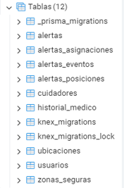
Testing with Postman::
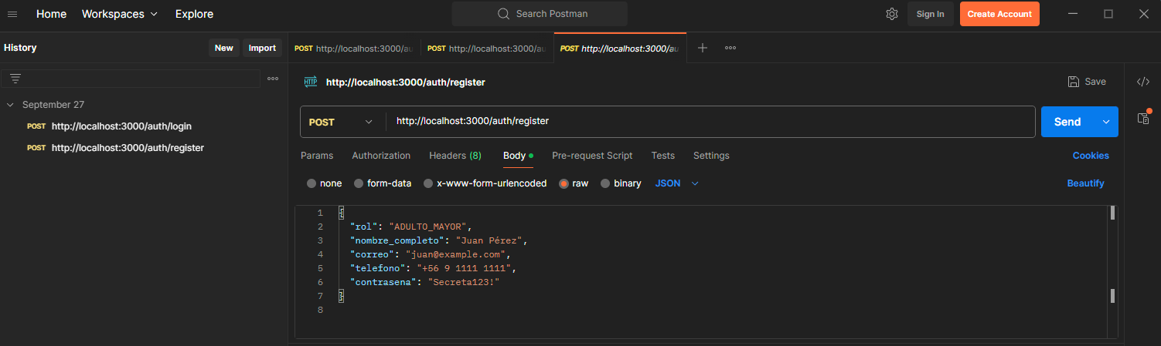
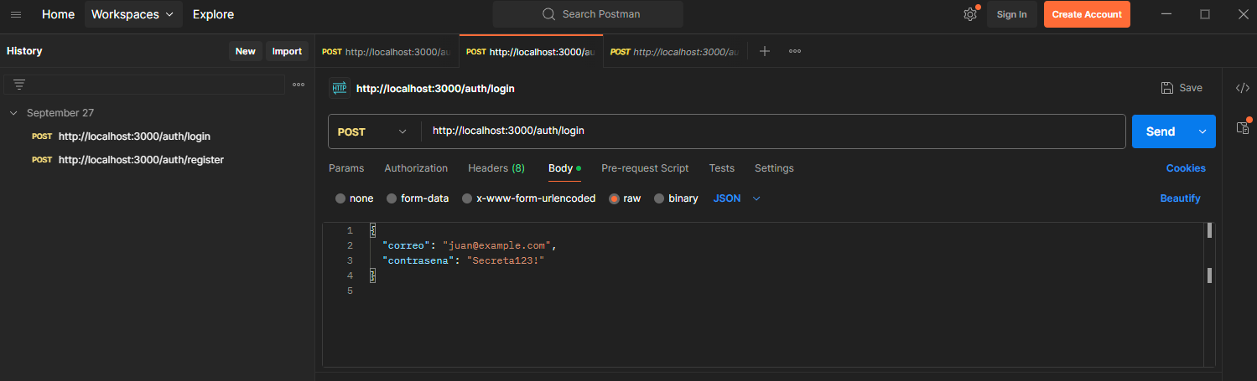

Account creation
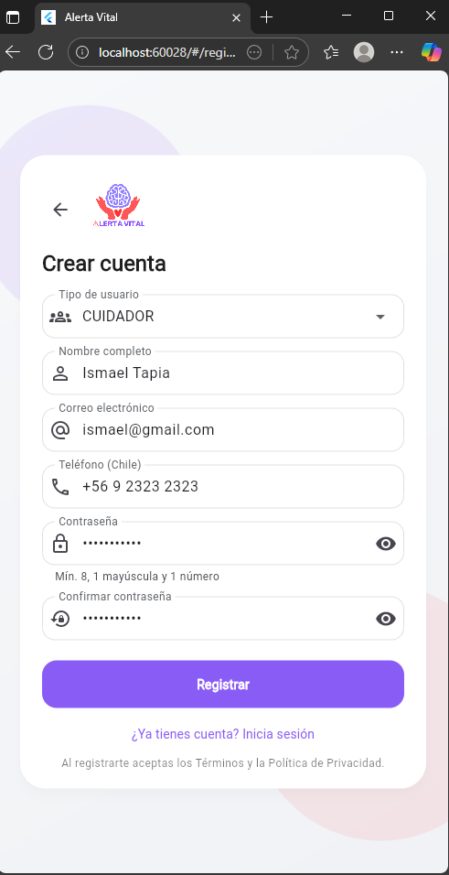

Login
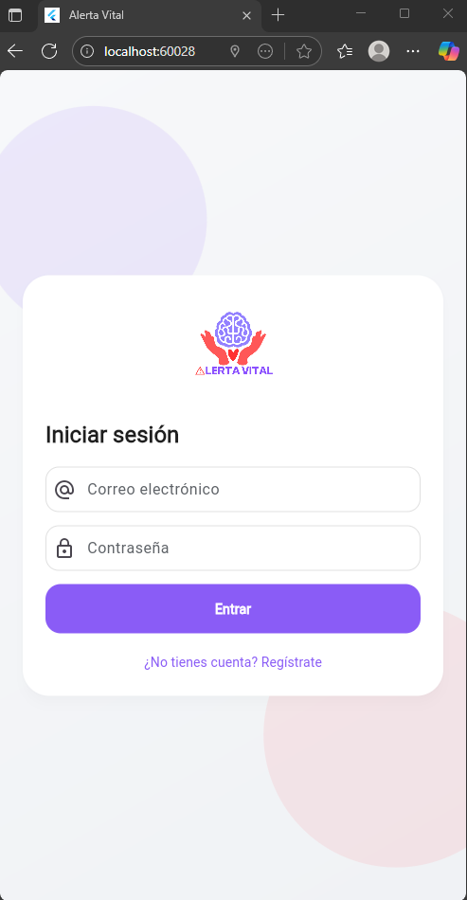

Emergency button (Senior Citizen)
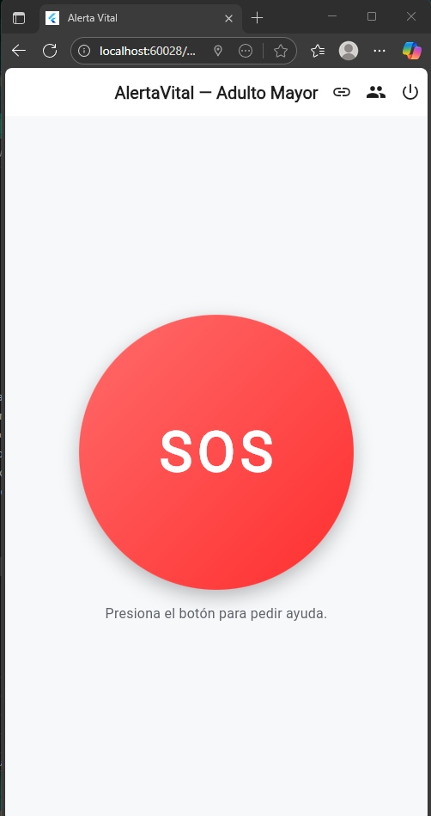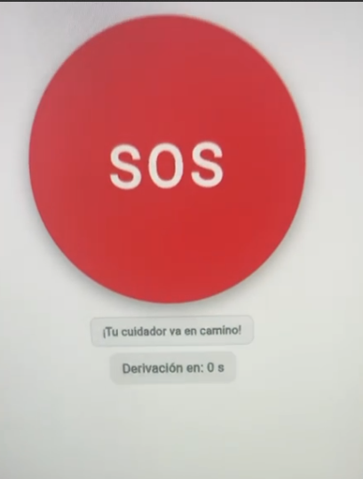

Alert (Caregiver)
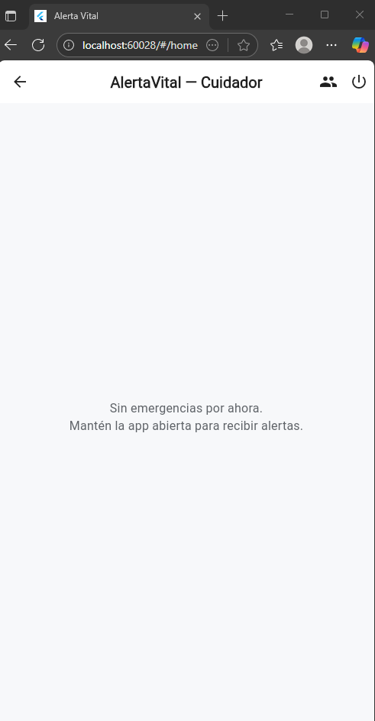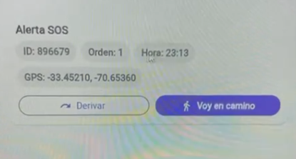

Map (with Google Maps for directions)
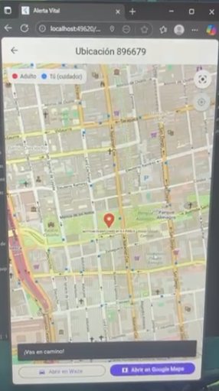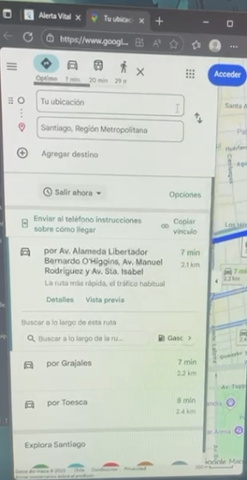

2. Monitoring the Work Plan

Sprint 1 Inicio y Planificación (COMPLETADO)
Plan de trabajo
Competence or units of competence | Activities | Resources | Duration of the activity | Person in charge | Observations | Progress status | Changes
Requirements Analysis | Brainstorming | Documentation | 2 DAYS | THE ENTIRE TEAM | Initial definition of the project | COMPLETED | -New features were added.
Technical Specification | Functional requirements gathering | Documentation | 2 DAYS | THE ENTIRE TEAM | Functionality documentation | COMPLETED | -requirements were removed and added
Technical Specification | Non-functional requirements survey | Documentation | 2 DAYS | THE ENTIRE TEAM | Requisitos de performance y seguridad | COMPLETED | -requirements were removed and added
Project Planning | Scope definition and MVP | Documentation | 4 DAYS | THE ENTIRE TEAM | Delimitation of the minimum viable product | COMPLETED | --The scope and MVP changed their focus.
Software Architecture | Architectural design and technology selection | Documentation | 4 DAYS | THE ENTIRE TEAM | Definition of technology stack | COMPLETED | -As this is a different approach, we opted for other technologies.

Sprint 2 Diseño y Prototipo (COMPLETADO)

Plan de trabajo
Competence or units of competence | Activities | Resources | Duration of the activity | Person in charge | Observations | Progress status | Changes
UI/UX design | Interface prototype creation | Figma | 6 DAYS | ISMAEL TAPIA | Prototype for end user | COMPLETED | -
Database Design | Database schema design | Node.js, PostgreSQL | 4 DAYS | DANTE VARGAS | Entity-relationship model | COMPLETED | -
API design | REST API Design | Postman | 4 DAYS | THE ENTIRE TEAM | Endpoint specification | COMPLETED | -

Sprint 3 Desarrollo - Núcleo del Sistema (COMPLETADO)
Plan de trabajo
Competence or units of competence | Activities | Resources | Duration of the activity | Person in charge | Observations | Progress status | Changes
Backend Development | (BD) Initial creation of the outline | Node.js, PostgreSQL | 6 DAYS | DANTE VARGAS | Physical implementation BD | COMPLETED | -
Backend Development | (BD) Creation of migrations and seeders | Node.js, PostgreSQL | 6 DAYS | THE ENTIRE TEAM | Test data and versioning | COMPLETED | -
Backend Development | Initial creation of the backend | Node.js, PostgreSQL | 6 DAYS | DANIEL JOFRE | Basic structure and models | COMPLETED | -
Frontend Development | Initial creation of the frontend | Flutter | 6 DAYS | DANIEL JOFRE | Basic structure and navigation | COMPLETED | -
Backend Development | Encoding user registration | Flutter | 6 DAYS | DANIEL JOFRE | Authentication and authorization | COMPLETED | -
Frontend Development | Registration form | Flutter | 6 DAYS | ISMAEL TAPIA | Registration forms | COMPLETED | -
Backend Development | Connecting older adults with contacts | Node.js, PostgreSQL | 6 DAYS | DANTE VARGAS | Relationships between entities | COMPLETED | -
Backend Development | Implement geolocation | Node.js, PostgreSQL | 6 DAYS | DANTE VARGAS | Location services , | COMPLETED | -
Frontend Development | Map API connection | Flutter | 6 DAYS | DANTE VARGAS | Map integration | COMPLETED | -
Backend Development | Creation of countdown for alerts | Node.js, PostgreSQL | 6 DAYS | DANIEL JOFRE | Timer system | COMPLETED | -
Frontend Development | Connection and countdown template | Flutter | 6 DAYS | ISMAEL TAPIA | Visual countdown interface | COMPLETED | -
Backend Development | Implementation of alert notification | Node.js, PostgreSQL | 5 DAYS | DANIEL JOFRE | Notification system | COMPLETED | -
Documentation | Progress documentation (Report) | Documentation | 5 DAYS | THE ENTIRE TEAM | Progress report progress report | COMPLETED | -

Sprint 4 Desarrollo - Funcionalidades Avanzadas e Integración (Planificado)

Plan de trabajo
Competence or units of competence | Activities | Resources | Duration of the activity | Person in charge | Observations | Progress status | Changes
Frontend Development | Improve countdown design | Flutter | 6 DAYS | ISMAEL TAPIA | Interface optimization | PENDING | -
Mobile Development | Push Notifications | Flutter | 6 DAYS | DANTE VARGAS | Push notification system | PENDING | -
Fullstack Development | Calendar integration | VisualStudio, flutter | 6 DAYS | DANIEL JOFRE | Medical appointment management | PENDING | -
Mobile Development | Medication alarm | VisualStudio, flutter | 6 DAYS | ISMAEL TAPIA | Medication reminders | PENDING | -
Backend Development | Implement safe zones | Node.js, PostgreSQL | 6 DAYS | DANTE VARGAS | Safe areas system | PENDING | -
Data Science | Creation of the dataset | Python | 11 DAYS | DANIEL JOFRE, DANTE VARGAS | Data collection and preparation | PENDING | -
Artificial Intelligence | Lightweight ML model integration | Python | 6 DAYS | THE ENTIRE TEAM | Decision Tree with exported coefficients | PENDING | -
Backend Development | Model Machine Learning | Python | 6 DAYS | THE ENTIRE TEAM | Location algorithm | PENDING | -
Backend Development | ML model integration | Python, Node.js, PostgreSQL | 2 DAYS | DANIEL JOFRE, DANTE VARGAS | System integration | PENDING | -
Safety | Email Verification | Email services | 2 DAYS | ISMAEL TAPIA | Email authentication | PENDING | -

SPRINT 5: Control de Calidad, Pruebas y Preparación para Producción (Planificado)

Plan de trabajo
Competence or units of competence | Activities | Resources | Duration of the activity | Person in charge | Observations | Progress status | Changes
Quality Assurance | Unit Tests | Jest, PHPUnit, Testing tools | 2 DAYS | DANTE VARGAS | Component validation | PENDING | -
Quality Assurance | Integration Tests | Testing suites, Environments | 2 DAYS | DANIEL JOFRE | Interface validation | PENDING | -
Usability Testing | Usability and Accessibility Testing | Test devices, Users | 2 DAYS | ISMAEL TAPIA | User validation | PENDING | -
Quality Control | Acceptance tests | Checklist, Acceptance Criteria | 2 DAYS | THE ENTIRE TEAM | Final validation | PENDING | -
Optimization | Performance and battery optimization | Profilers, Monitoring Tools | 2 DAYS | ISMAEL TAPIA | Improved efficiency | PENDING | -
DevOps | Production Environment Configuration | Servers, CI/CD, Docker | 2 DAYS | DANIEL JOFRE | Server preparation | PENDING | -
DevOps | Hosting and Deployment | Cloud services, CI/CD pipelines | 3 DAYS | THE ENTIRE TEAM | Production implementation | PENDING | -

SPRINT 6: Cierre y Documentación (Planificado)

Plan de trabajo
Competence or units of competence | Activities | Resources | Duration of the activity | Person in charge | Observations | Progress status | Changes
Technical Documentation | Technical Documentation | Documentation tools, Templates | 3 DAYS | THE ENTIRE TEAM | Technical manual | PENDING | -
User Documentation | User Manual | Guides, Screenshots, Tutorials | 3 DAYS | THE ENTIRE TEAM | Guides for end users | PENDING | -
Communication | Final Presentation and Demo | Slides, Demos, Visual material | 3 DAYS | THE ENTIRE TEAM | Material for stakeholders | PENDING | -
Project Management | Final Project Report | Templates, Metrics, Reports | 3 DAYS | THE ENTIRE TEAM | Closing report | PENDING | -

3. Adjustments based on monitoring
Delve deeper into the observations in your work plan. Analyze the planned activities and point out which aspects facilitated or hindered the execution of the plan. Discuss how you addressed and/or will address the obstacles. Finally, point out the adjustments you made to the work plan based on this analysis.

Factors that have facilitated and/or hindered the development of my work plan:
To optimize coordination and overcome the availability challenges identified during the development of the project, where it was not always possible to have all members present simultaneously in classes or work sessions, we have formally established mandatory weekly meetings. These sessions, complemented by a clear asynchronous communication protocol, allow us to align objectives, distribute tasks effectively, resolve impediments collaboratively, and maintain a cohesive workflow, thus ensuring the continuous and coordinated progress of the project despite individual schedule constraints.

Adjusted or eliminated activities:
The feedback provided by the professor in charge was essential in strategically reorienting our project, which led us to completely revise and transform the initial schedule. This process involved eliminating activities that did not align with the new approach, restructuring priority tasks, and modifying deadlines, allowing us to optimize our efforts toward better-defined objectives and ensure a more efficient and focused execution of the project.
Following the feedback received, we eliminated three activities from the previous plan:
Fall detection: due to the high technical complexity and specialized hardware requirements that exceeded our scope (TIME)
SMS via WhatsApp: does not fulfill the purpose of the application. Alerta Vital is designed as an automated emergency system, without relying on manual user intervention.
Immobility detection: Due to usability issues and possible false alarms.
These adjustments allowed us to focus resources on viable core functionalities, optimizing the team's time and effort toward the main objectives of the project.

Activities that you have not started or are delayed:
As a team, we have successfully completed all activities according to the established schedule, achieving most milestones within the planned deadlines and reaching the objectives defined for this stage of the project. Although we encountered some complications at the beginning of sprint 3, but we managed to catch up with the activities, which reflects our commitment, coordination, and ability to execute the work, despite getting a little sidetracked at the beginning.

